**Experiment no: 05**

**Date: 13.08.2025**

EDA - Data Visualization with Matplotlib

# AIM:

To understand and implement basic data visualization techniques using **Matplotlib**,

including **line charts**, **bar charts**, and **histograms** as part of exploratory data analysis.

# Code:

# Import necessary libraries import matplotlib.pyplot as plt

# Sample data for plotting x = [1, 2, 3, 4, 5] y =

[10, 12, 8, 14, 7]

#

# 1. Line Chart #

plt.figure(figsize=(6, 4)) plt.plot(x, y, marker='o', color='blue', linestyle='--') plt.title('Line Chart Example') plt.xlabel('X-axis') plt.ylabel('Y-axis') plt.grid(True)

plt.show()

#

# 2. Bar Chart #

categories = ['A', 'B', 'C', 'D', 'E'] values = [5, 7, 3, 8, 4]

plt.figure(figsize=(6, 4)) plt.bar(categories, values, color='green') plt.title('Bar Chart Example') plt.xlabel('Categories')

plt.ylabel('Values') plt.show()

#

# 3. Histogram #

import numpy as np

# Generate random data for histogram data = np.random.normal(50, 10, 1000) # mean=50, std=10

plt.figure(figsize=(6, 4)) plt.hist(data, bins=20, color='purple', edgecolor='black') plt.title('Histogram Example') plt.xlabel('Value Range') plt.ylabel('Frequency') plt.show()

# output:

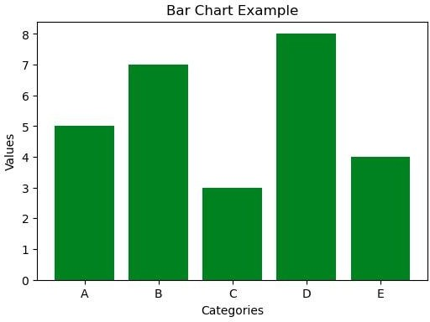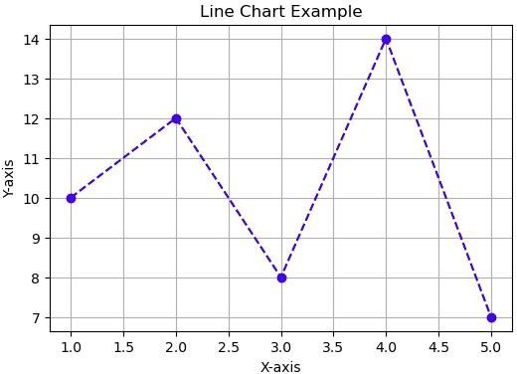

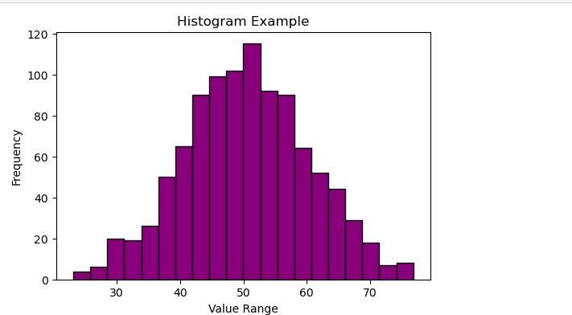

**RESULT:**

Basic plotting techniques using **Matplotlib** were successfully implemented. The line chart showed trends over a sequence, the bar chart displayed categorical comparisons, and the histogram visualized the distribution of numerical data.